**Web technologies -lab**

**Cycle sheet-1**

**Name:**Y.sai sathwik

**Register number:** 17MIS0344

**Slot:** L33+L34 **Faculty:** Vanmathi.C

**1. HTML Text formatting exercises**

1a) Print the squares of the numbers 1 - 20. Each number should be on a separate line, next to it the number 2 superscripted, an equal sign and the result.

**Code:**

<html>

<body bgcolor="skyblue">

<h1>THE SQUARES OF 1,2,3,4,5....20</h1>

1<sup>2</sup> = 1

<br />

2<sup>2</sup> = 4

<br />

3<sup>2</sup> = 9

<br />

4<sup>2</sup> = 16

<br />

5<sup>2</sup> = 25

<br />

6<sup>2</sup> = 36

<br />

7<sup>2</sup> = 49

<br />

8<sup>2</sup> = 64

<br />

9<sup>2</sup> = 81

<br />

10<sup>2</sup> = 100

<br />

11<sup>2</sup> = 121

<br />

12<sup>2</sup> = 144

<br />

13<sup>2</sup> = 169

<br />

14<sup>2</sup> = 196

<br />

15<sup>2</sup> = 225

<br />

16<sup>2</sup> = 256

<br />

17<sup>2</sup> = 289

<br />

18<sup>2</sup> = 324

<br />

19<sup>2</sup> = 361

<br />

20<sup>2</sup> = 400

</body>

</html>

**Output:**

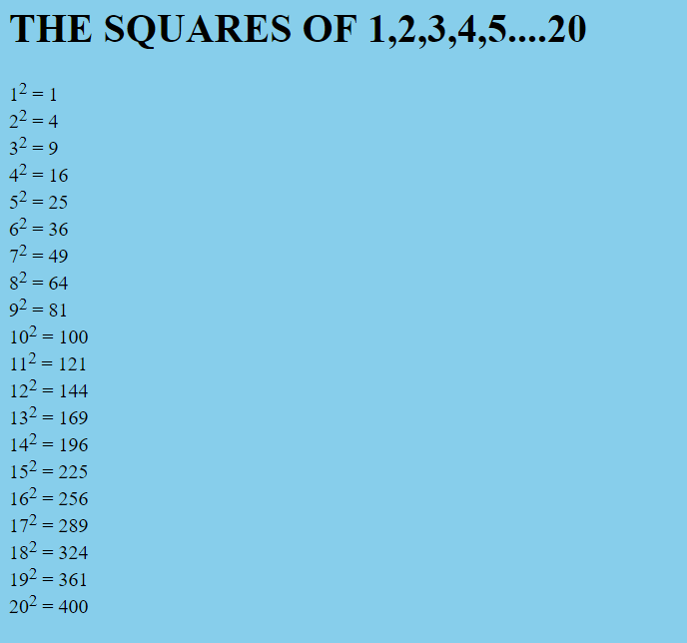

1b) Prints 10 names with a line break between each name. The list should be alphabetized, and to do this place a subscripted number next to each name based on where it will go in the alphabetized list. (Example: Alan1). Print first, the unalphabetized list with a subscript number next to each name, then the alphabetized list. Both lists should have an <h1> level heading.

**Code:**

<html>

<body>

<h1>Unalphabetized list</h1>

Bill<sub>3</sub>

<br />

Roger<sub>5</sub>

<br />

Sandra<sub>6</sub>

<br />

Stacy<sub>7</sub>

<br />

William<sub>10</sub>

<br />

Thomas<sub>8</sub>

<br />

Wendy<sub>9</sub>

<br />

Jane<sub>4</sub>

<br />

Andy<sub>1</sub>

<br />

Anna<sub>2</sub>

<h1>Alphabetized list</h1>

Andy

<br />

Anna

<br />

Bill

<br />

Jane

<br />

Roger

<br />

Sandra

<br />

Stacy

<br />

Thomas

<br />

Wendy

<br />

William

</body>

</html>

**Output:**

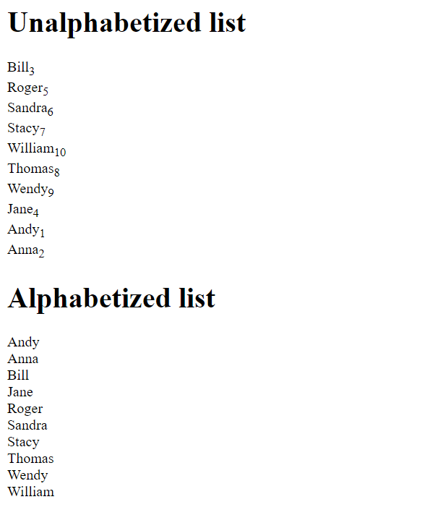

1c) Print two lists with any information you want. One list should be an ordered list, the other list should be an unordered list

**Code:**

<html>

<body bgcolor="black">

<div style="color:white; font-size:30;">

<b>Hardware devices</b>

<ol type="I">

<li>CD-ROM drive</li>

<li>DVD drive</li>

<li>Hard disk</li>

<li>Modem</li>

</ol>

<b>Web languages</b>

<ul type="square">

<li>HTML</li>

<li>Javascript</li>

<li>PHP</li>

<li>Java</li>

</ul>

</div>

</body>

</html>

**Output:**

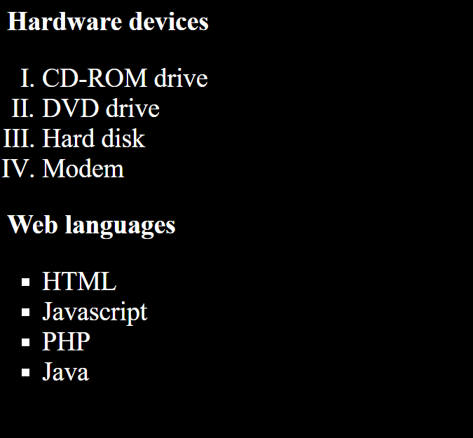

1d)Print a list which starts with 7 with the type i

**Code:**

<html>

<head>

<title>1d</title>

</head>

<body bgcolor="skyblue;">

<ol type="i" start="7">

<li>Tajmahal</li>

<li>Indian gate</li>

<li>Red fort</li>

</ol>

</body>

</html>

**Output:**



1e) Prints an h1 level heading followed by a horizontal line whose width is 100%. Below the horizontal line print a paragraph relating to the text in the heading

**Code:**

<html>

<body bgcolor="skyblue">

<h1>Question 1e register number-17MIS0344</h1>

<hr width="100%" />

<p >

A delicious confection that is quite popular when it comes to

sweets. Cookies come in various varieties including chocolate

chip, raisin, and macademia nut. A very different type of

cookie is a small text file stored on a user's computer by

a web server.This is the web tech lab assignmnet register number

17MIS0344

</p>

</body>

</html>

**Output:**

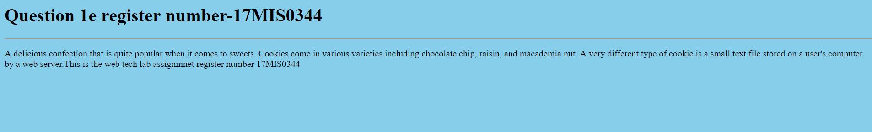

1f)Print a definition list with 5 items

**Code:**

<html>

<head>

<title>1f</title>

</head>

<body bgcolor="skyblue">

<dl>

<dt>HTML</dt>

<dd>A Hyper text markup language</dd>

<dt>Pen</dt>

<dd>A writing tool</dd>

<dt>Lettuce</dt>

<dd>A vegetable</dd>

<dt>Technology</dt>

<dd>The development of tools which serve as a means to

certain objectives</dd>

<dt>Bibliophilic</dt>

<dd>Lover of books</dd>

<dt>Capital of India</dt>

<dd>Delhi</dd>

</dl>

</body>

</html>

**Output:**

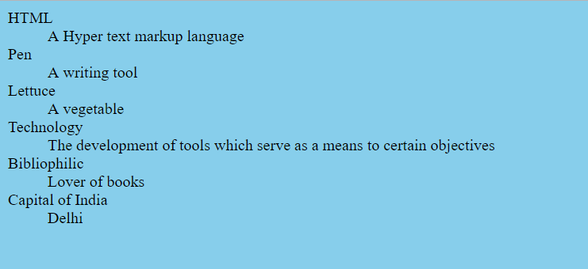

1g) Print two addresses in the same format used on the front of envelopes (senders address in top left corner, receivers address in the center)

**Code:**

<html>

<body bgcolor="skyblue">

<address>

Sai sathwik Y.<br />

1234 Anim Street<br />

P.O. Box 22222 17MIS0344

</address>

<br /><br />

<center>

<address>

17MIS0340 A. Person<br />

5555 Street Avenue<br />

Katpadi,vit university,vellore.

</address>

</center>

</body>

</html>

**Output:**

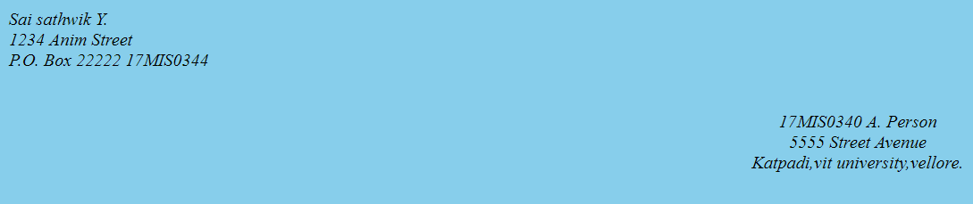

1h)Print ten acronyms and abbreviations of your choosing, each separated by two lines. Specify the data that the abbreviations and acronyms represent

**Code:**

<html>

<body bgcolor="yellow">

<h1>17MIS0344</h1>

<abbr title="Abstract">Abstr.</abbr>

<br /><br />

<abbr title="Biochemistry">Biochem.</abbr>

<br /><br />

<abbr title="Example">Ex.</abbr>

<br /><br />

<abbr title="Literature">Lit.</abbr>

<br /><br />

<abbr title="Mathematics">Math.</abbr>

<br /><br />

<acronym title="World Wide Web Consortium">W3C</acronym>

<br /><br />

<acronym title="Institute of Electrical

and Electronic Engineers">IEEE</acronym>

<br /><br />

<acronym title="International Standards Organization">

ISO

</acronym>

<br /><br />

<acronym title="Hyper Text Markup Language">HTML</acronym>

<br /><br />

<acronym title="Beginners All Purpose

Symbolic Instruction Code">BASIC

</acronym>

<p>

Move your mouse over an abbreviation or acronym to get more data.

</p>

</body>

</html>

**Output:**

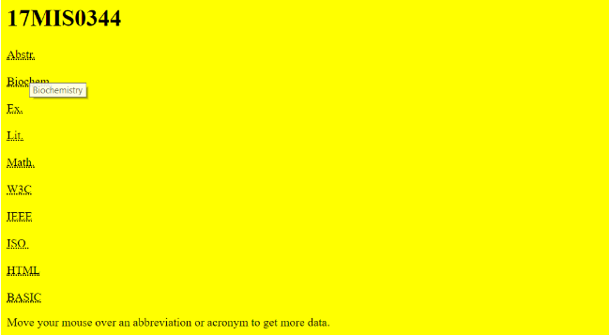

**2. HTML IMAGE EXERCISES:**

2a)Display five different images. Skip two lines between each image. Each image should have a title.

**Code:**

<html>

<head>

<title>17mis0344</title>

</head>

<body>

<h1>1ST IMAGE</h1>

<img src="1.jpg" width="100px height="130px"/>

</br>

</br>

<h1>2nd IMAGE</h2>

<img src="4.jpg" width="100px" height="130px"/>

</br>

</br>

<h1>3rd IMAGE</h2>

<img src="2.jpg" width="100px" height="130px"/>

</br>

</br>

<h1>4th IMAGE</h2>

<img src="3.png" width="100px" height="130px"/>

</br>

</br>

<h1>5th IMAGE</h2>

<img src="15.png" width="100px" height="130px"/>

</br>

</br>

</body>

</html>

**Output:**

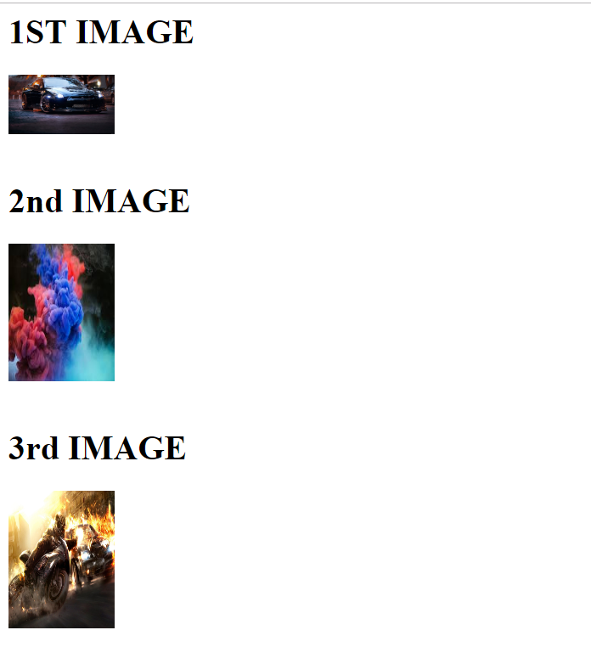

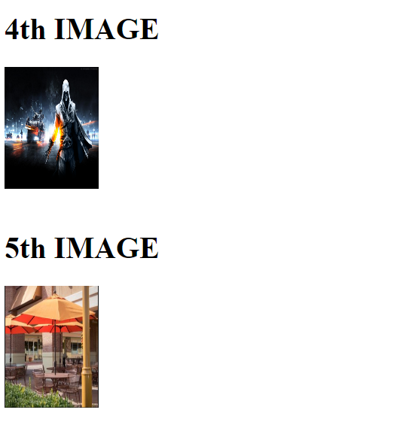

2b) Display an image that has a border of size 2, a width of 200, and a height of 200.

**Code:**

<html>

<body>

<title>17MIS0344</title>

</head>

<h1>Image</h1>

<img src="1.jpg" width="200" height="200" alt="car" style="border:2px solid red;" />

</body>

</html>

**Output:**

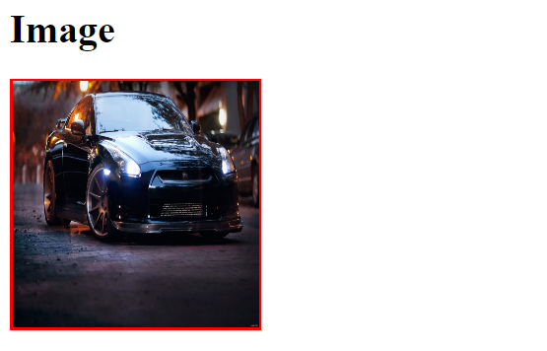

2c)Display the image towards the right corner of the webpage

**Code:**

<html>

<body>

<title>17MIS0344</title>

</head>

<h1 align="right" >Image</h1>

<img src="1.jpg" width="200" height="200" alt="car"

align="right"style="border:2px solid red ;" />

</body>

</html>

**Output:**



3. Program to illustrate Nested ordered list and Definition lists

**Code:**

<html>

<head>

<title>17MIS0344</title>

</head>

<body bgcolor="skyblue">

<h1>Lists</h1>

<ol type="a">

<li>Soild grey banner along the top of the browser window</li>

<ol type="i">

<li>Company logo</li>

<li>product image</li>

</ol>

<li>A text based navigation window</li>

<ol type="i">

<li>Links to each of the site’s web documents</.li>

</ol>

<li>A content area</li>

<ol type="i">

<li>A heading that identifies page content</li>

<li>A paragraph for displaying content</li>

<li>A copyright notice</li>

</ol>

</ol>

</body>

</html>

**Output:**

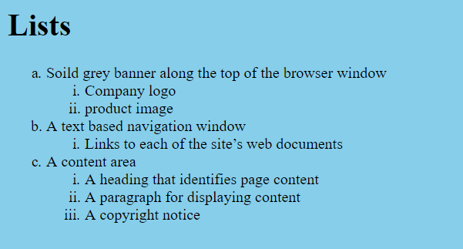

3b)

<html>

<head>

<title>Nested and definition list 17MIS0344</title>

</head>

<body bgcolor="skyblue">

<h1 align="center">To illustrate Nested and Definition list Tags</h1>

<hr width="100%"/>

<h2>An ordered nested list</h2>

<ol type="1">

<li>Coffee</li>

<li>Tea</li>

<ol type="a">

<li>Black tea</li>

<li>Green tea</li>

<ol type="i">

<li>China</li>

<li>Africa</li>

</ol>

</ol>

<li>Milk</li>

</ol>

</body>

</html>

**Output:**

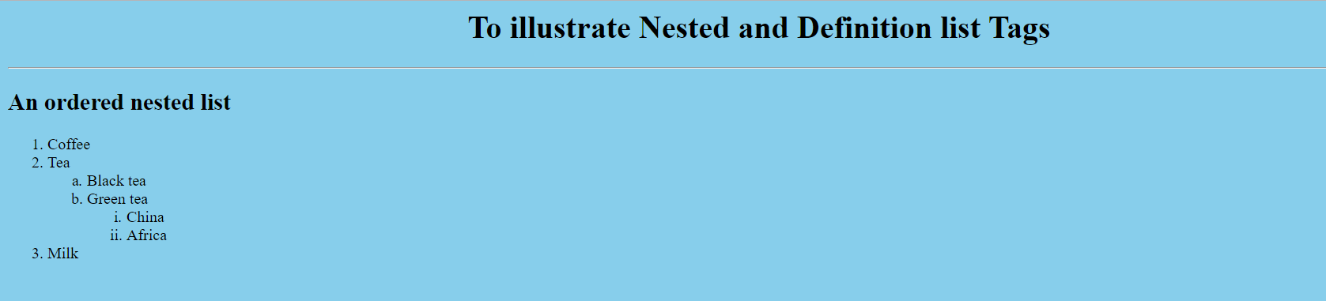

**4.** Design the following page using table tags.



**Code:**

<html>

<head>

<title>17MIS0344</title>

</head>

<body bgcolor="skyblue">

<h1>Fruits example</h1>

<table border="2">

<tr>

<td colspan="4"><i><h1 align="center">Fresh Fruits</h1></i></td>

</tr>

<tr>

<td colspan="3">It has long been known that a diet</br>that

includes atleast a few servings</br>of fresh

fruit every day will help</br>keep you healthy,

fit and trim.

</td>

<td><img src="22.png"/></td>

</tr>

</table>

</body>

</html>

**Output:**

**`**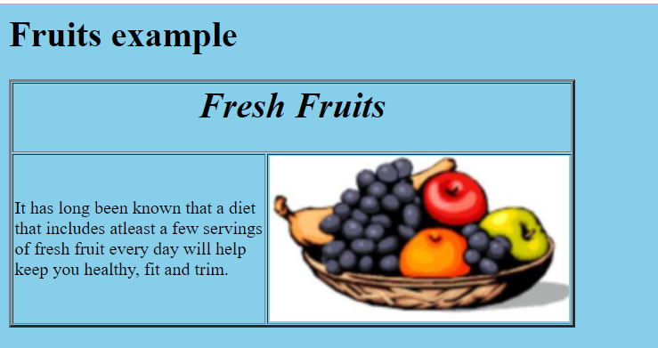

4b)

**Code:**

<html>

<head>

<title>17MIS0344</title>

</head>

<body>

<table border="2">

<tr bgcolor="yellow"">

<td><b>Indicator channel<br>3rd and 2nd bit</b></td>

<td><b>Channel 1 1<sup>st</sup> bit</b></td>

<td><b>Channel 2 0<sup>th</sup>bit</b></td>

</tr>

<tr bgcolor="grey">

<td>00</td>

<td>no hidden data</td>

<td>no hidden data</td>

</tr>

<tr bgcolor="green">

<td>01</td>

<td>no hidden data</td>

<td>no hidden data</td>

</tr>

<tr bgcolor="orange">

<td>10</td>

<td>no hidden data</td>

<td>no hidden data</td>

</tr>

<tr bgcolor="voilet">

<td>11</td>

<td>no hidden data</td>

<td>no hidden data</td>

</tr>

</table>

</body>

</html>

**Output:**

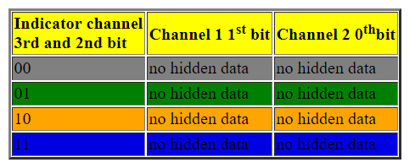

**5.** Develop static pages (using Only HTML) of an online Book store. The pages should resemble: www.amazon.com. The website should consist of the following pages.

• Home page

• Registration and user Login

• User Profile Page

• Books catalog

• Shopping Cart

• Payment By credit card

• Order Conformation

**Code:**

<html>

<head>

<title>www.amazon.com</title>

</head>

<frameset rows="20%,80%">

<frame name="top" src="b.html">

<frameset cols="20%,80%">

<frame name="left" src="a.html" >

<frame name="right" src="c.html">

</frameset>

</frameset>

</html>

<html>

<head>

<title>www.amazon.com</title>

</head>

<body background="Media/1.jpg">

</br>

</br>

</br>

<ul>

<a href="ab.html" target="_New" ><li><font color="#FF0000">USER LOGIN</font></li></a></br>

<a href="bc.html"><li><font color="#FF0000">USER profile</font></li></a></br>

<a href="ca.html"><li><font color="#FF0000">BOOKS CATALOGUE</font></li></a></br>

<a href="ws.html"><li><font color="#FF0000">SHOPPING CART</font></li></a></br>

<a href="we.html"><li><font color="#FF0000">ORDER CONFIRMATION</font></li></a></br>

<a href="qa.html"><li><font color="#FF0000">PAYMENT</font></li></a></br>

</body> </html>

<html>

<head>

<title>www.amazon.com</title>

<h1 align="CENTER">USER LOGIN FORM

<body bgcolor="#00FFFF">

<p align="center"><u>ALREADY U HAVE AN ID "LOGIN " OTHERWISE "REGISTER"</u></p></br>

<form name="amazonentryform" action="proc.html" method="post">

user id:

&nbsp&nbsp&nbsp&nbsp<input type="text"/>

</br>

</br>

password:

<input type="password"/>

</br>

</br>

<a href="xx.html">home</a>&nbsp&nbsp

<input type = "submit" value= "submit"/>&nbsp&nbsp&nbsp<a href="xy.html">register</a>

</form>

</body>

</html>

<html>

<head>

<title>www.amazon.com</title>

</head>

<body background="Media/2.jpg" text="red">

</br>

</br>

<h1 align="center">AMAZON BOOK WORLD</h1>

</body>

</html>

<html>

<head>

<title>www.amazon.com</title>

<body text="FF00FF">

</br>

</br>

</br>

</br>

</br>

</br>

<h1 align="center"><font face="verdana">Welcome</br></br>&nbsp&nbsp&nbsp&nbsp&nbsp&nbsp&nbsp&nbsp&nbsp2</br></br>&nbsp&nbsp&nbsp&nbsp&nbsp&nbsp&nbsp&nbsp&nbsp&nbsp&nbsp&nbsp&nbsp&nbsp&nbsp&nbspAmazon.com</font </h1>

</body>

</html>

<html>

<head>

<title>my form</title>

</head>

<body bgcolor="skyblue">

<h1 align="center">*---**---REGISTRATION---*---*</h1>

<hr width="100%"/>

<div align="center">

<form action="ee.html" method=Post">

&nbsp&nbsp&nbsp&nbsp&nbsp&nbsp&nbsp&nbspName:&nbsp&nbsp&nbsp&nbsp<input type="text" name="e" /></br></br>

&nbsp&nbspGender:<input type="radio" name="gender"/>Male&nbspFemale<input type="radio" name="gender"/></br></br>

Occupation<select>

<option>Student</option>

<option>homemaker</option>

<option>Engineer</option>

</select></br></br>

</br>

Address<text area width="300" height="50"/>

Phone<input type="text" name="e"/></br>

Email id<input type="text" name="r"/></br>

Hobbies<input type="check box" name="c"/>Browsing<input type="check box" name="c"/>Reading books<input type="check box" name="c"/>Drawing<input type="check box" name="c"/>Gardening</br>

User id<input type="text" name="f"/></br>

Password<input type="password"/></br>

Retypepassword<input type="password"/></br>

<a href="back.html">Back</a>&nbsp&nbsp&nbsp&nbsp&nbsp<input type="submit" value="submit"/>&nbsp&nbsp&nbsp&nbsp<input type="reset"/>

</form>

</body>

</html>

<html>

<head>

<title>gg</title>

</head>

<body>

<table border="2" width="500px" height="350px">

<tr bgcolor="grey">

<td>sno</td>

<td>User</br>Name</td>

<td>DOB</td>

<td>Address</td>

<td>Occupation</td>

</tr>

<tr bgcolor="grey">

<td>1</td>

<td>Ramu p</td>

<td>12th jan</br>1980</td>

<td>hno123Mg road,vij</td>

<td>Engineer</td>

</tr>

<tr bgcolor="grey">

<td>1</td>

<td>nikki</td>

<td>12th jan</br>1980</td>

<td>hno123Mg road,vij</td>

<td>doctor</td>

</tr>

<tr bgcolor="grey">

<td>1</td>

<td>neeraj p</td>

<td>12th jan</br>1980</td>

<td>hno123Mg road,vij</td>

<td>Engineer</td>

</tr>

<tr bgcolor="grey">

<td>1</td>

<td>sathwik</td>

<td>12th jan</br>1980</td>

<td>hno123Mg road,vij</td>

<td>Engineerbtech</td>

</tr>

<tr bgcolor="grey">

<td>1</td>

<td>tulasi</td>

<td>12th jan</br>1980</td>

<td>hno123Mg road,vij</td>

<td>Engineerbtech</td>

</tr>

</table>

</body>

</html>

**Output:**

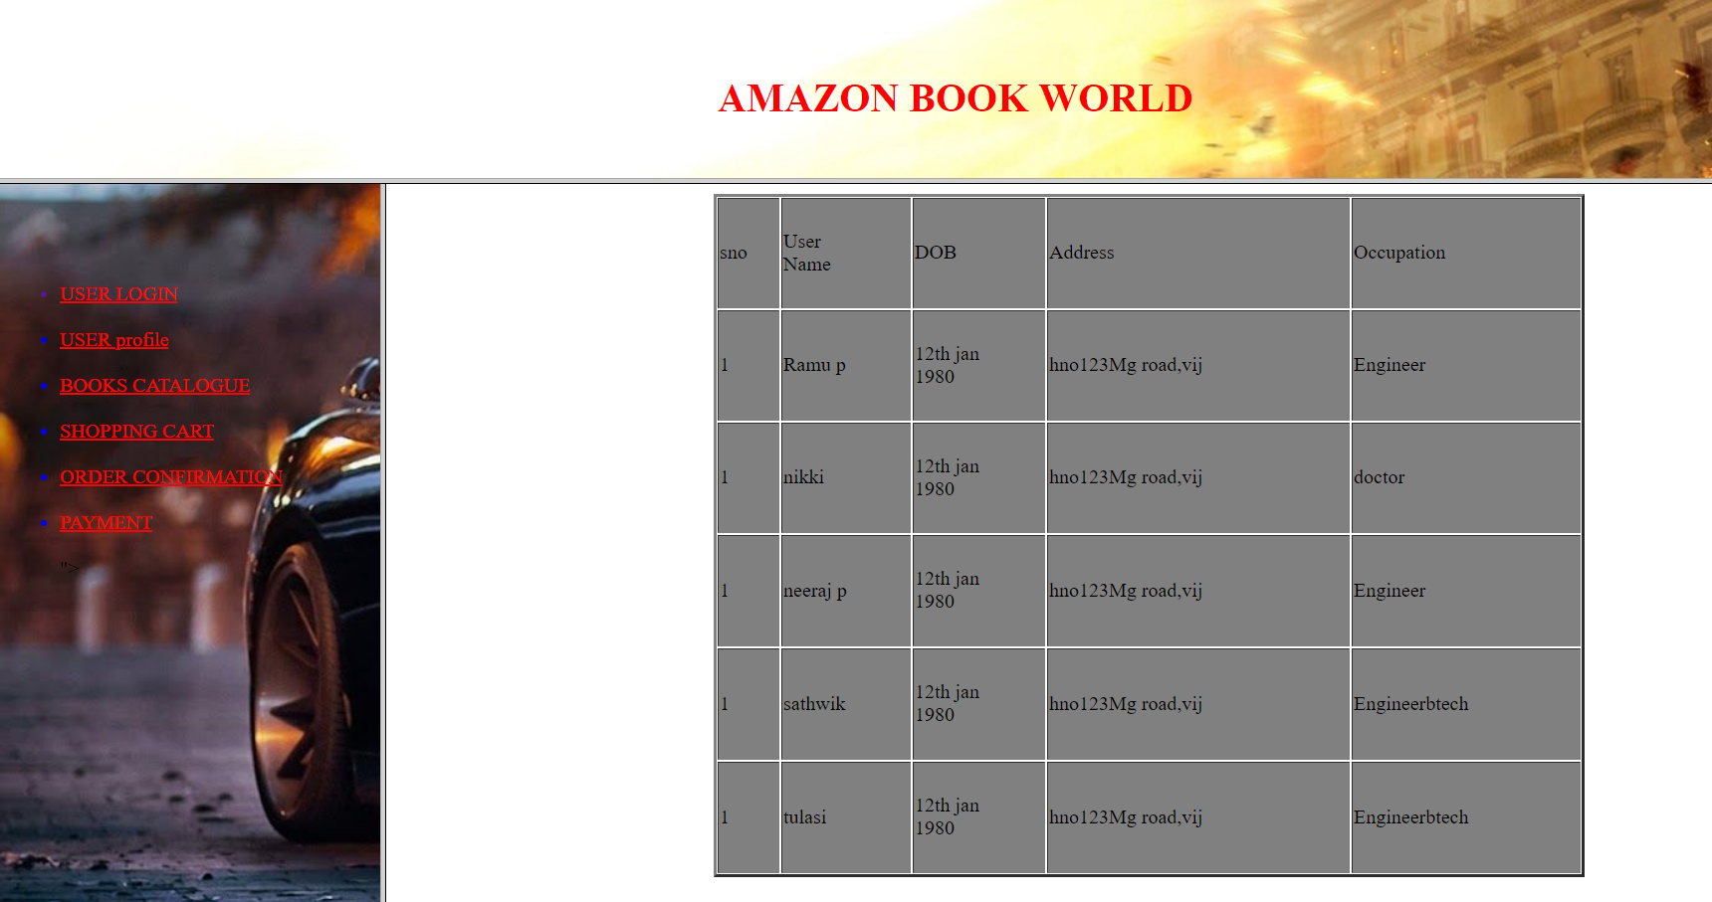

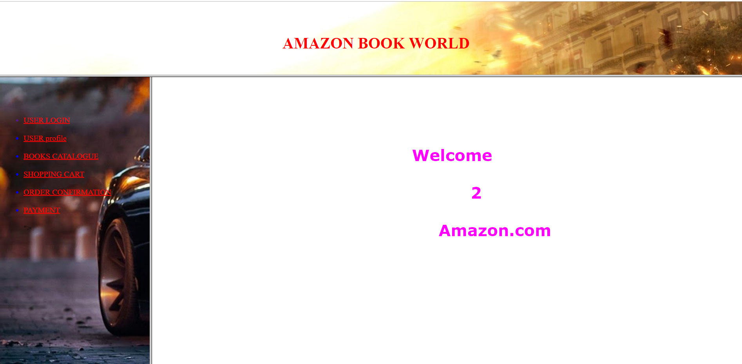

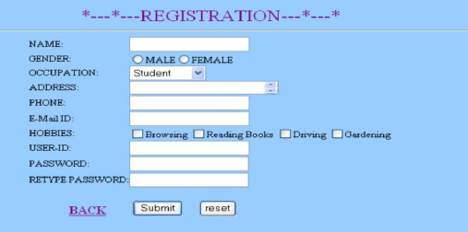

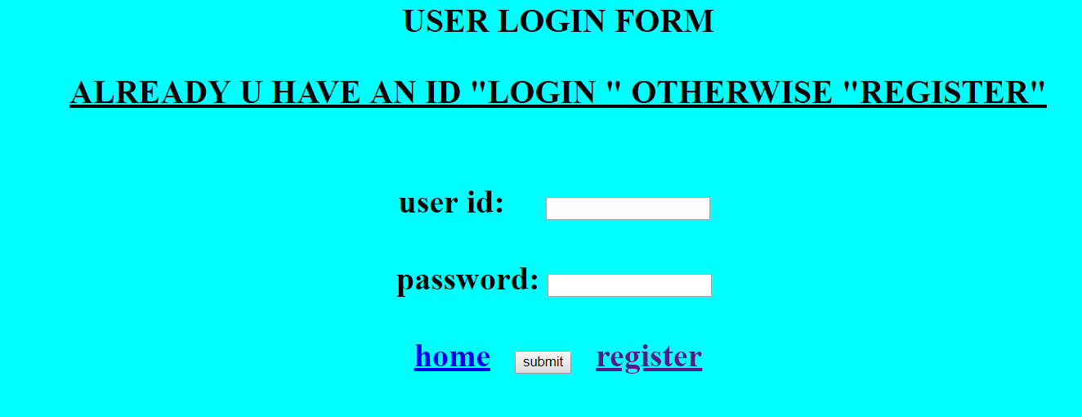

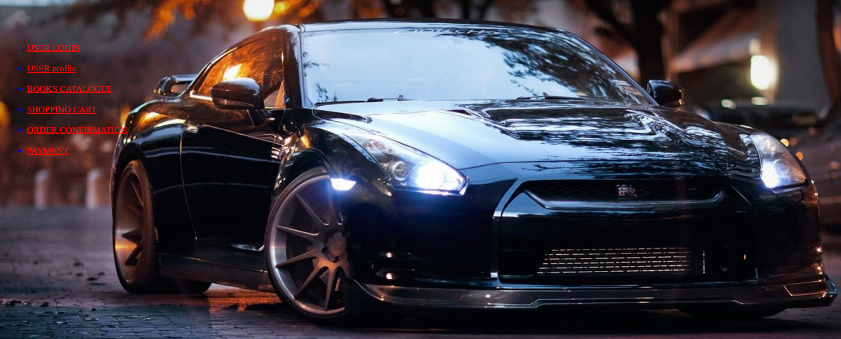

**6.** Design a Math Quiz Page using HTML and CSS.

• The page will present the visitors with instructions for taking a 10-question math quiz along with the quiz questions itself.

• Answers to each question are provided at the bottom of the web page. The visitors can jump back and forth between questions and answers by clicking on individual questions and answers.

• Specifically, every question is individually linked to its corresponding answer at the bottom of the page and every answer is linked back to its corresponding question.

• Improve the web page navigation by adding an extra link at the top and bottom of the document, which when clicked jumps the user from the top to the bottom of the web page and vice versa.

• Expand the text that provides the user with instructions, explaining the number of questions that must be answered in order to pass the quiz.

• Decorate the web page by experimenting with the rules located in its internal style sheet, assigning different font colors, font types, and sizes.

**Code:**

<html>

<head>

</head>

<body bgcolor="tan">

<br /><br /><br />

<h1 align="center"><pre>***Select the questions to start exam***</pre></h1>

</body>

</html>

<html>

<head>

</head>

<body bgcolor="tan">

<br /><br />

<h2><pre>1. How Many Digits Are There In Hindu-Arabic System?</pre></h2>

&nbsp&nbsp&nbsp&nbsp

<form action="" method="post">

<input type="radio" name="maths" value"on">10

<br /><br />

<input type="radio" name="maths" value"on">20

<br /><br />

<input type="radio" name="maths" value"on">30

<br /><br />

<input type="radio" name="maths" value"on">40

</form>

<table border=1 align="right">

<tr>

<td>14</td>

<td><pre>:</pre></td>

<td>58</td>

</tr>

</table>

&nbsp&nbsp&nbsp&nbsp&nbsp&nbsp

</body>

</html>

<html>

<head>

</head>

<body bgcolor="tan">

<br /><br />

<h2><pre>10.Among The Following Which Natural Number has no predecessor?</pre></h2>

&nbsp&nbsp&nbsp&nbsp

<form action="" method="post">

<input type="radio" name="maths" value"on">100

<br /><br />

<input type="radio" name="maths" value"on">200

<br /><br />

<input type="radio" name="maths" value"on">1

<br /><br />

<input type="radio" name="maths" value"on">0

<table border=1 align="right">

<tr>

<td>01</td>

<td><pre>:</pre></td>

<td>45</td>

</tr>

</table>

</br>

</br>

</br>

</br>

<div align="right" >

<a href="end.html" target=_New><img src="1.jpg" height="70px" width="70px"/></a>

&nbsp

&nbsp

&nbsp

&nbsp

&nbsp

</div>

</form>

</body>

</html>

<html>

<head>

</head>

<body bgcolor="tan">

<br /><br />

<h2><pre>10.Among The Following Which Natural Number has no predecessor?</pre></h2>

&nbsp&nbsp&nbsp&nbsp

<form action="" method="post">

<input type="radio" name="maths" value"on">100

<br /><br />

<input type="radio" name="maths" value"on">200

<br /><br />

<input type="radio" name="maths" value"on">1

<br /><br />

<input type="radio" name="maths" value"on">0

</body>

</html>

<html>

<head>

<frameset rows="30%,70%">

<frame name="top" src="6thtop.html">

<frameset cols="20%,80%">

<frame name="left" src="6thtwo.html">

<frame name="right" src="6thmiddlemain.html">

</frameset>

</frameset>

</head>

</html>

<html>

<head>

</head>

<body style="background-image:url(quizz1.jpg)">

</body>

</html>

<html>

<head>

</head>

<body bgcolor="gray">

<h1 ><pre><u>QUESTIONS:-</pre></u></h1>

<table border="3" width=250px height="150px">

<tr>

<td><a href="6thmiddleone.html" target="right"><h1 align="center">1</h1></a></td>

<td><a href="" target="6thmiddleone.html"><h1 align="center">2</h1></a></td>

<td><a href="" target="right"><h1 align="center">3</h1></a></td>

<td><a href="" target="right"><h1 align="center">4</h1></a></td>

<td><a href="" target="right"><h1 align="center">5</h1></a></td>

</tr>

<tr>

<td><a href="" target="right"><h1 align="center">6</h1></a></td>

<td><a href="" target="right"><h1 align="center">7</h1></a></td>

<td><a href="" target="right"><h1 align="center">8</h1></a></td>

<td><a href="" target="right"><h1 align="center">9</h1></a></td>

<td><a href="6thmiddleten.html" target="right"><h1 align="center">10</h1></a></td>

</tr>

</table>

</body>

</html>

<html>

<head>

</head>

<body bgcolor="skyblue">

<ol type="1" start="1">

<li>a</li>

<li>c</li>

<li>d</li>

<li>a</li>

<li>d</li>

<li>b</li>

<li>c</li>

<li>a</li>

<li>c</li>

<li>b</li>

</ol>

</body>

</html>

<html>

<head>

</head>

<body>

<a href="ans.html"><h1>view your answers</h1></a>

</body>

</html>

<html>

<head>

</head>

<body style ="background-image:url(quizz.jpg)">

<form>

<h1 align="center">INSTRUCTIONS</h1>

<br/>

<br/>

<br/>

<ul>

<li><h3 >This Quizz Consists Of 10 Questions</h3></li>

<li><h3>Each Question carries one mark</h3></li>

<li><h3 >Test Will Finish In 15min</h3></li>

<li><h3 >Every Question Is Single Correct Awnser Type</h3></li>

<li><h3 >Read the Questions Carefully And write answers</h3></li>

<li><h3>Read the instructions carefully and press submit button to start quizz</h3></li>

&nbsp&nbsp&nbsp&nbsp&nbsp&nbsp&nbsp&nbsp

<a href="6thone.html">

<input type="button" value="submit"/>

</a>

</form>

</body>

</html>

**Output:**

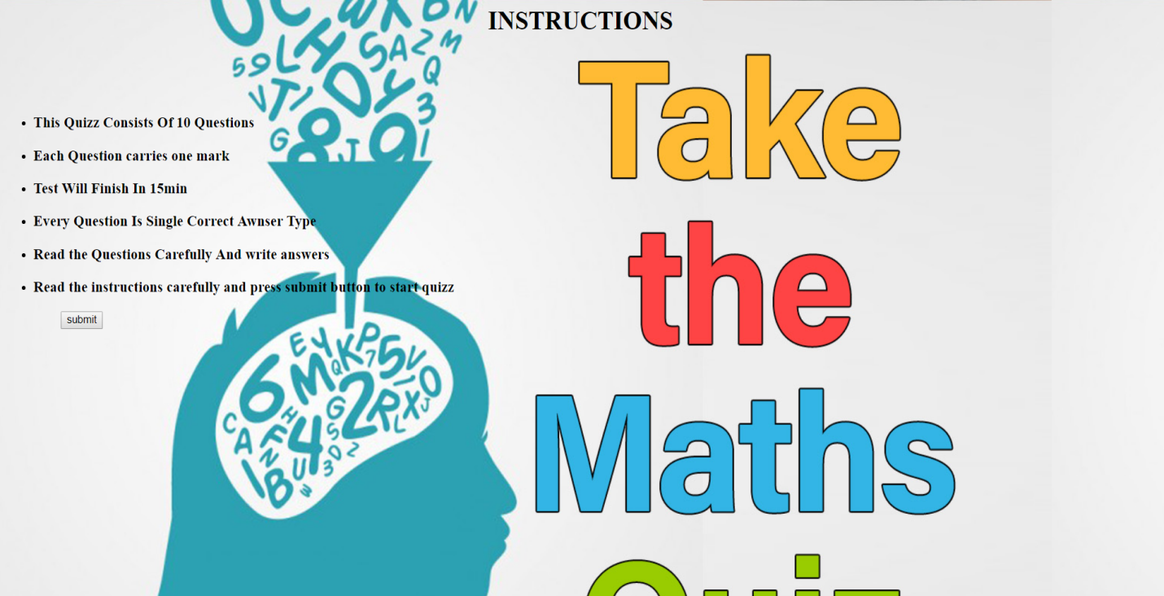

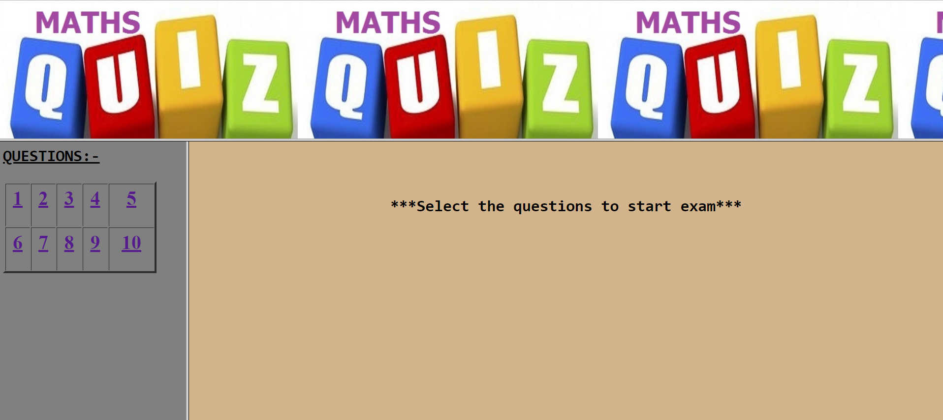

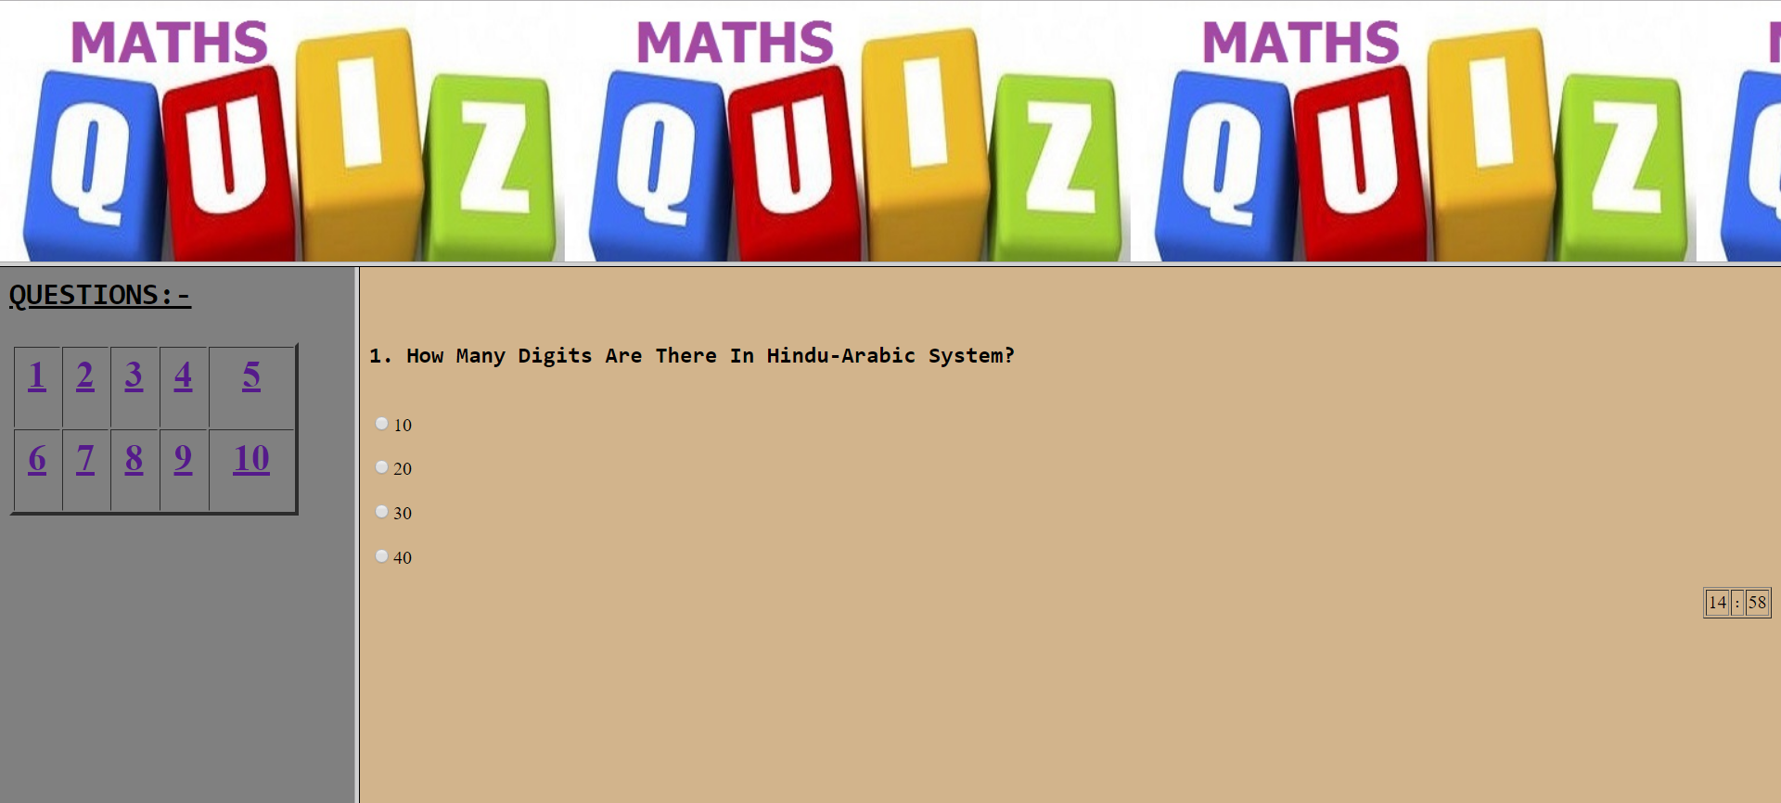

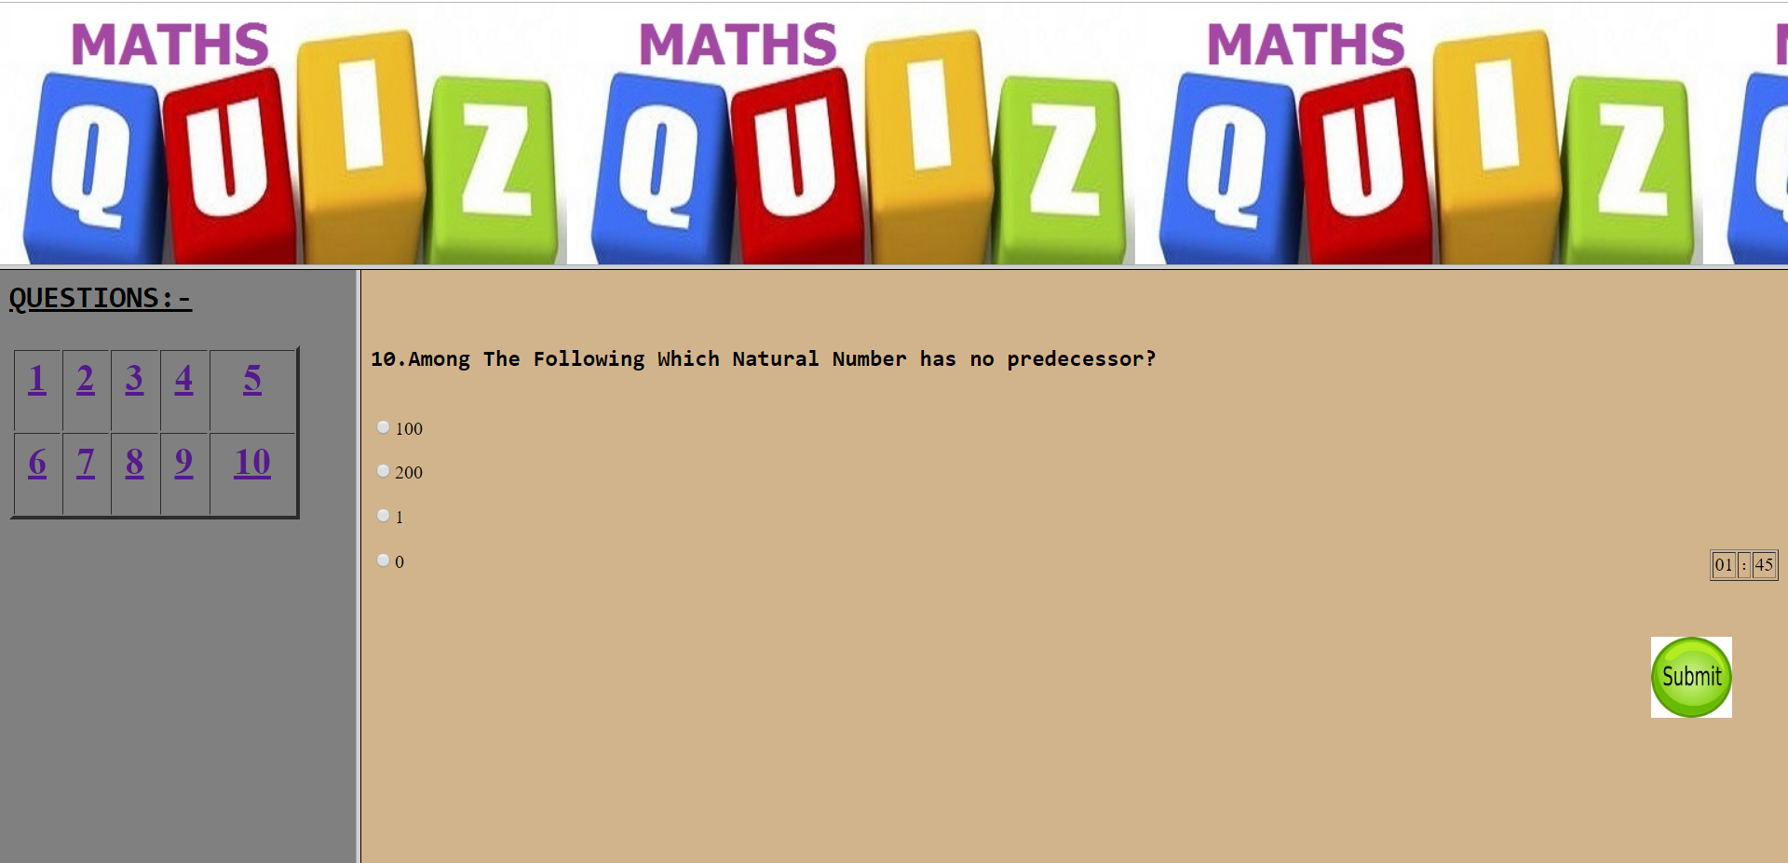





7) The town of Chesapeake Haven, Maryland, is home to a local landmark restaurant, the Berger Street Grille. The restaurant offers casual dining in a spacious waterfront setting and serves several hundred diners on any given evening. Although the restaurant is famous for its grilled meat dishes, its location near the Chesapeake River and the Atlantic Ocean makes the restaurant a favorite for seafood lovers as well. Ben O’Brien, the owner of the restaurant, has asked for your assistance in creating a Web page for the Berger Street Grille.

• Open the file berger_t4 from the website. This is the data file, you will work on this file to modify the design of the page so that it meets the following criteria:

• The page should have an internal CSS.

• The bullets should be square shaped instead of the current circular shape.

• The background color should be black and font color should be white.

• Center the text and create a class in the CSS file for centering text and images.

• All the headings as well as footer should be in yellow font color.

• Font-size is 1.2em and left and right margins are 10em.

**Code:**

**Html file:**

<html>

<head>

<title>chesapake.com</title>

<link rel="stylesheet" type="text/css" href="imp.css"/>

</head>

<body style="background-color:black; color:white;">

<h1 >Welcome to Berger Street Grille</h1>

</br>

&nbsp&nbsp&nbsp&nbsp&nbsp&nbsp&nbsp<b><font size="+2" color="yellow">Overview</font></b>&nbsp&nbsp&nbsp&nbsp&nbsp&nbsp&nbsp&nbsp&nbsp&nbsp&nbsp&nbsp&nbsp&nbsp&nbsp&nbsp&nbsp&nbsp&nbsp&nbsp&nbsp&nbsp&nbsp&nbsp&nbsp&nbsp&nbsp&nbsp&nbsp&nbsp&nbsp&nbsp&nbsp&nbsp&nbsp&nbsp&nbsp&nbsp&nbsp&nbsp&nbsp&nbsp&nbsp&nbsp&nbsp&nbsp&nbsp&nbsp&nbsp&nbsp&nbsp&nbsp&nbsp&nbsp&nbsp&nbsp&nbsp&nbsp&nbsp&nbsp&nbsp&nbsp&nbsp&nbsp&nbsp&nbsp&nbsp&nbsp&nbsp&nbsp&nbsp&nbsp&nbsp&nbsp&nbsp&nbsp&nbsp&nbsp&nbsp&nbsp&nbsp&nbsp&nbsp&nbsp&nbsp&nbsp&nbsp&nbsp&nbsp&nbsp&nbsp<b><font size="+2" color="yellow">Garden restaurent</font></b>

</br>

</br>

<div class="sh">

<div >

<img src="12.png" width="400px" height="250px" style="border:2px solid white;" align="left" />

</div>

<div>

<img src="15.png" width="400px" height="250px" style="border:2px solid white;" align="center" />

</div>

<div align="center">

<span><font size="+2"><i><font size="+4" style="font-weight:bold; letter-spacing:2px; color:yellow;">ABOUT....</br></font>The town of Chesapeake Haven, Maryland, is home to a local.... landmark restaurant, the Berger Street Grille. The restaurant offers casual dining in a spacious waterfront setting and serves several hundred diners on any given evening. Although the restaurant is famous for its grilled meat dishes, its location near the Chesapeake River and the Atlantic Ocean makes the restaurant a favorite for seafood lovers as well.</font></i></span>

</div>

</div>&nbsp&nbsp&nbsp&nbsp&nbsp<b><font size="+2" color="yellow">Location</font></b>&nbsp&nbsp&nbsp&nbsp<b><font size="+2" color="yellow">Items available...</font></b>&nbsp&nbsp&nbsp&nbsp&nbsp&nbsp&nbsp&nbsp&nbsp &nbsp&nbsp&nbsp&nbsp&nbsp&nbsp&nbsp&nbsp&nbsp&nbsp&nbsp&nbsp&nbsp&nbsp&nbsp&nbsp&nbsp&nbsp&nbsp&nbsp<b><fontsize="+2" color="yellow">Cost and offers available..</font></b>

</br>

</br>

<div class="sathwik">

<div >

<table border="2px" cellpadding="3px" width="400px" align="left">

<tr style="color:white;">

<td colspan="3"><p style="font-weight:bold;">Land mark</p></td>

<td colspan="3">chesapake river</td>

</tr>

<tr style="color:white;">

<td colspan="3"><p style="font-weight:bold;">City</p></td>

<td colspan="3">Ontario</td>

</tr>

<tr style="color:white;">

<td colspan="3"><p style="font-weight:bold;">Country</p></td>

<td colspan="3">Canada</td>

</tr>

</table>

</div>

<div>

<div class="si">

<ul>

<li style="list-style-type:square; "><font size="+1">Burgers</font></li>

<li style="list-style-type:square; "><font size="+1">Pizza</font></li>

<li style="list-style-type:square; "><font size="+1">all types of sea food</font></li>

</ul>

<ul>

<li style="list-style-type:square; "><font size="+1">Canadian spl</font></li>

<li style="list-style-type:square; "><font size="+1">cheese items</font></li>

<li style="list-style-type:square; "><font size="+1">Noodles</font></li>

</ul>

&nbsp&nbsp&nbsp&nbsp<img src="4.png" width="80px" height="80px"/>

</br>

</div>

</div>

&nbsp&nbsp&nbsp&nbsp&nbsp&nbsp&nbsp&nbsp&nbsp&nbsp&nbsp&nbsp<table border="2px" width="200px">

<tr>

<td>Burgers</td>

<td>30-40$</td>

</tr>

<tr>

<td>Pizza</td>

<td>20-40$</td>

</tr>

<tr>

<td>Sea food</td>

<td>100-200$</td>

</tr>

</table>

&nbsp&nbsp&nbsp&nbsp<font size="+2">OFFERS!..</font>

&nbsp&nbsp&nbsp<table border="2">

<tr>

<td>amount-50%on a buy of a pack</tr>

</tr>

<tr>

<td>1 pizza free on a buy of 3 pizzas</td>

</tr>

<tr>

<td>50% amount less on a buy of combo</td>

</tr>

</table>

</div>

<div class="oo">

<div>

<img src="44.webp" width="300px" height="130px"/>

</div>

<div>

<p style="letter-spacing:2px;">THIS RESTAURENT HAS A WELL DEFINED AND WELL MANUFACTURED RESORTS WITH

GOOD VENTILATION AND ALSO BUILT </br></br>&nbsp&nbsp&nbsp NEAR BY CHESAPAKE HAVEN TOWN......... </P>

<font size="+2" style="color:yellow;">&nbsp&nbsp&nbsp&nbspTHANK YOU!..VISIT AGAIN</font>&nbsp&nbsp&nbsp&nbsp&nbsp <img src="55.jpg" width="350px" height="60px" align="center"/>

</div>

</body>

</html>

**CSS file:**

b

{

width:100px;

height:100px;

color:white;

text-transform:capitalise;

text-decoration:none;

font-style:italic;

letter-spacing:3px;

}

h1

{

color:white;

text-align:center;

font-style:italic;

}

h3

{

color:white;

font-style:italic;

letter-spacing:3px;

}

.sh

{

text-align:left;

display:flex;

flex-direction: row;

margin:20px;

}

.sathwik

{

text-align:center;

display:flex;

flex-direction: row;

margin:20px;

}

.si

{

display:flex;

flex-direction:row;

}

.oo

{

flex-direction:row;

display:flex;

text-indent:0.5cm;

}

.po

{

display:flex;

flex-direction:row;

}

**Output:**

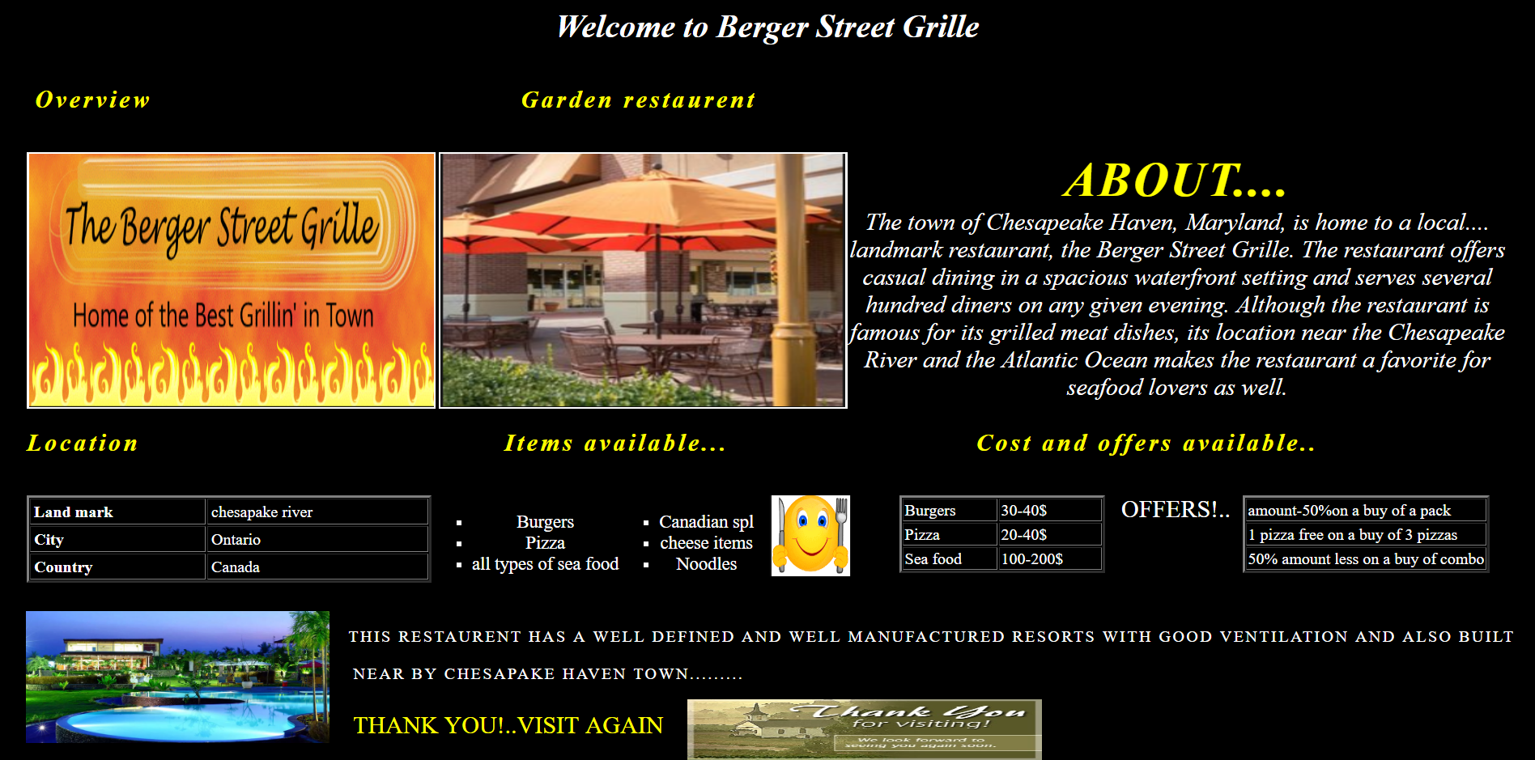

8. Write the HTML code to create a personal web site with the frame-based navigation structure. The web site must contain a frameset with a header, navigation bar, and at least three different pages.

Code:(welcome1.html)

<html>

<head>

</head>

<frameset rows="25%,75%">

<frame src="bubba_world..html">

<frameset cols="30%,70%">

<frame src="hyperlink.html">

<frame src="bubba.html">

</frameset>

</frameset>

</html>

Code:(bubba_world..html)

<html>

<head>

</head>

<body bgcolor="skyblue">

<h1 style="color:blue" align="center"><font face="Axure Handwriting" >Bubba's world</font></h1>

</body>

</html>

Code:(hyperlink.html)

<html>

<head>

</head>

<body bgcolor="skyblue">

<a href="home.html">Home</a>

</br>

</br>

<a href="Photo gallery.html">Photo Gallery</a>

</br>

</br>

<a href="Links.html">Links</a>

</body>

</html>

Code:(bubba.html)

<html>

<head>

</head>

<body bgcolor="skyblue">

Hi! My name is&nbsp;<b>Bubba</b> and I live in

<font color="red" size="10"><u>Red</u></font>

<font color="blue" size="8"><u>neck</u></font>

<font color="green" size="8"><u>ville</u></font>

</br>

<h1>Redneckville</h1>

</br>

I am very proud to be a resident of <u>Redneckville.</u>

</br>

It is best place to live if you are a redneck and your are dentally

</br>

challenged(that is, your teeth are really bad like mine).Here's what I like

</br>

about the place:

</br>

<ul>

<li>It's in the <small>middle</small> of nowhere</li>

<li>You don't have to brush your <font color="yellow" size="5">TEETH</font></li>

<li>You can always marry a close relative</li>

</ul>

</body>

</html>

Code:(home1.html)

<html>

<head>

</head>

<body>

<h1>HOME</h1>

</body>

</html>

Code:(links.html)

<html>

<head>

</head>

<body>

<h1>Links</h1>

</body>

</html>

Code:(photo gallery.html)

<html>

<head>

</head>

<body>

<h1>Photo gallery</h1>

</body>

</html>

**Output:**

